# **Service Brief:** Regulatory Compliance

The story so far…

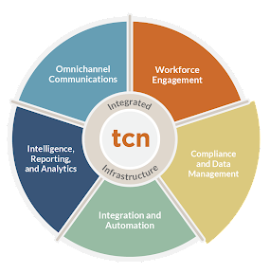There’s an old saying that goes, “A stitch in time saves nine.” This adage teaches us it’s better to solve a problem when it’s small so that it doesn’t become a bigger one later on. Oddly enough, it’s as apt to the modern contact center as it ever was to the seamstress.

Each ‘stitch’ is a rule or regulation that prevents non-compliance, reduces risk, and staves off litigation. For example, *No calls before 8 a.m. or after 9 p.m.* The aim of these rules and regulations is to keep everyone safe and the playing field level. But they also present a challenge - violations can be costly, even if it’s a simple slip-up.

Contact center operators can be fined as much as $1,000 per incident when a phone number in the DNC list lands in the call queue. Or another $1,000 when an agent accidentally violates outbound dialing restrictions because of Daylight Saving Time. These fines can add up quickly, especially if trebled damages apply, which can triple the amount of the fine. Still, they pale in comparison to the cost of poor data handling or unintended data sharing. Those oversights may result in the levying of fines that can close the contact center doors permanently.

As such, compliance experts take stringent measures to stay up-to-date on changes made to the rules and regulations. It is essential to communicate those changes to managers who are responsible for applying them to the contact center. It’s also necessary to be able to prove compliance wherever and whenever auditors require it. Sadly, both can be a problem when the controls are rule sets written in code, but neither the manager nor the auditors can read them.

Still, that’s not the only reason managers suffer with compliance. It’s tough to spend hours before sunrise, manually scrubbing restricted numbers out of the contact list. It’s even tougher to see one of those numbers appear in an outbound report following the broadcast and not know why. But even more concerning is the questions that it brings up. What else was missed? What kind of impact does it have on the agents or on the contact center as a whole? Those are the kinds of questions that keep managers up at night.

Ultimately, it’s the customer who pays the price. If agents are thinking about compliance issues, they’re not thinking about the customer. One violation can lead to another and then another - just like stitches coming apart at the seams. The logic only follows that the agent will eventually forget something really important, like redacting social security numbers during a recording or inadvertently sharing customer data. By then it’s too late.

## Simplify Compliance with TCN

Just because compliance is compulsory doesn’t mean it needs to be complex - or even written in code. That’s where TCN comes in. Our flagship product, TCN Operator, draws all the best contact center tools into a suite of applications and services that modernizes customer communication.

Of these applications, **Natural Language Compliance** (shown below) simplifies the compliance tasks that eat up a manager’s time, and eliminates the compliance risks that strike at the heart of the contact center.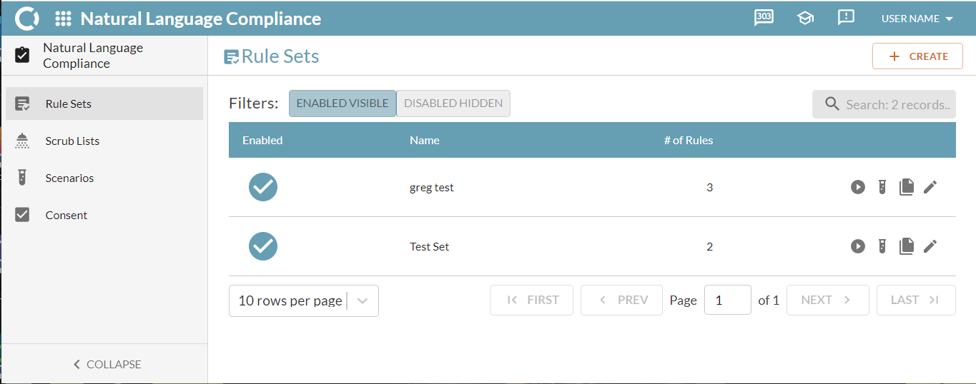

TCN simplifies compliance by segmenting it into four intuitive categories: *Rule Sets*, *Scrub Lists*, *Scenarios*, and *Consent*. The following sections contain a quick overview of each.

### Rule Sets (Natural Language)

Author your own rule sets just as easily as any hired gun coding them. The expression builder in TCN Operator reads English just as well as you can write it, while the auto-complete feature functions to predict the current word selection and ensure proper writing conventions. See below.

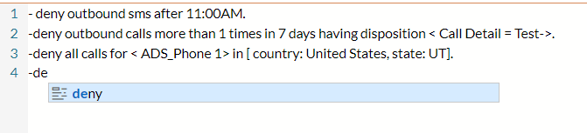

**NOTE:** Natural language can be a major benefit when it comes time to prove compliance. Rule sets written in a natural language reduce the friction points between auditors and managers, subsequently shortening the time to compliance.

### Scrub Lists

Scrub practically anything out of your contact lists - not just phone numbers. TCN’s scrub lists are equipped to handle it. Scrub away unresponsive email addresses before starting an email campaign. Scrub away a block of numbers for just a day or two as opposed to putting them in the DNC list. Scrub away customers with negative disposition codes before broadcasting a campaign. Scrub away entire area codes. Get creative. All it takes is a scrub list, a contact list, a rule set, and Voila! Those potential contact violations are a thing of the past.

### Scenarios

Try your rule sets on for size. Create test calls and messages at-will and then run the rule sets against them. Don’t wait to put them into production before figuring out something is wrong. Test one rule set or several under real-world scenarios with “Should Deny” parameters and “Should Allow” parameters that set the rules of the game. Change those parameters and run the scenario again. Find the peace of mind that comes with knowing your rule sets are ironclad.

### Consent

TCPA regulations regarding contacting customers are clear - consent is required for any channel on which a consumer prefers to be contacted. In other words, the consumer must opt-in to one or more channels before the contact center can lift a finger to make contact. TCN Operator simplifies this process through a simple web interface set up for adding or revoking consent.

## Conclusion

Utilization of TCN’s Compliance and Data Management applications help provide the necessary insulation and required protections to mitigate regulatory and litigious actions against your business. Proper usage of TCN’s Compliance and Data Management suite of tools allows your organization to operate confidently, with the knowledge that your business is operating in full adherence with best-in-class industry Compliance and Data Management security standards. Appropriate Compliance and Data Management practices assuredly assist in protecting your bottom-line profitability.

## Common Regulatory Bodies - Compliance

|  |  |
| --- | --- |
| United States | * [Telephone Consumer Protection Act](https://www.fcc.gov/sites/default/files/tcpa-rules.pdf) (TCPA) * [Fair Debt Collection Practices](https://www.tcn.com/blog/regulation-f-recap/) (Regulation F) * [Healthcare Insurance Portability & Accountability Act](https://www.hhs.gov/hipaa/index.html) (HIPAA ) * [Health Information Technology for Economic & Clinical Health Act](https://www.hhs.gov/hipaa/for-professionals/special-topics/hitech-act-enforcement-interim-final-rule/index.html) (HITECH) * Other regulations as required by state/ local regulatory bodies |
| Canada | * [The Canadian Radio-television and Telecommunications Commission](https://laws.justice.gc.ca/eng/regulations/SOR-79-555/page-1.html) (CRTC) |
| UK/EU (European Union) | * [United Kingdom Regulatory Requirements](https://www.ofcom.org.uk/home) (Ofcom) * [General Data Protection Regulation](https://ico.org.uk/for-organisations/guide-to-data-protection/guide-to-the-general-data-protection-regulation-gdpr/) (GDPR) |